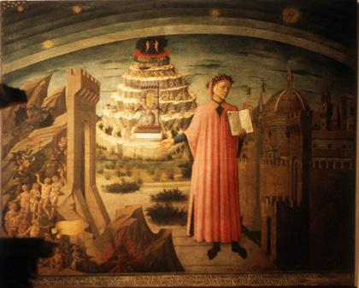
Dante’s Inferno Project – Written Report

Name:

Part 1 – Study Questions on “The Divine Comedy”

Question 1
What do the three "Dante Worlds"--hell, purgatory, and paradise--mean to you? How do you envision them, if at all? How do you think they might relate to one another and to the world(s) in which we live?
Begin your reaction here:
Question 2
Dante literally faces a mid-life crisis. What problems or issues do you associate with such an event? Describe any recent representations--in movies, books, the news, and so on--of some sort of mid-life crisis?
Begin your reaction here:
Question 3
From Dante's presentation of Francesca and Paolo, we are encouraged to consider the place of moral responsibility in depictions of love, sex, and violence in our own day. We can certainly discuss music, television, movies, and advertising (as well as literature) in these terms. Who is more (or less) responsible and therefore accountable for unacceptable attitudes and behavior in society: the creators and vehicles of such messages or the consumers and audiences?
Begin your reaction here:
Question 4
As a relatively privileged European man of the late Middle Ages, Dante certainly shares - despite his intellect and imagination - many views that we moderns might rightly consider unenlightened. These could include religious and ethnic intolerance, a reductive attitude toward women, and a heterosexist understanding of love and sexuality. In some respects - for instance, his advocacy of the empire (and opposition to more democratic, republican ideas) - he could be considered reactionary even for his own time and place.
- While we might think of ourselves as enlightened, open-minded people today, what might our descendants say about us a century or two from now?
- What specific issues or attitudes do you think will change so much in the future that our current views may come to be seen as "medieval"?
Begin your reaction here:
Part 2 – Technical Justification
In this section, please describe why you created the image that you did, and give a description of the PhotoShop techniques that you used in this project. Also include your reaction to the project – did you enjoy it, what, if anything, did you gain from this assignment?
Begin your reaction here:

